**Optimizing Data Management at Dollarama: Harnessing the Power of ETL and Cloud Architecture**

**Introduction**

In the fast-paced retail landscape, the ability to process vast amounts of data into actionable insights is a game-changer. At Dollarama, a robust data pipeline and cloud architecture form the core of this capability, enabling efficient data management and analysis. This article delves into the intricacies of Dollarama's Extract, Transform, and Load (ETL) processes and its strategic deployment of Microsoft Azure's cloud services.

**The ETL Process: Foundation of Data Management**

1. **Data Extraction: Sourcing Data from Multiple Origins**
   * Dollarama extracts data from various sources, including sales terminals, online transactions, customer feedback forms, and supply chain databases.
   * Microsoft Azure Data Factory automates and streamlines the extraction process, ensuring continuous data flow into the central data store.

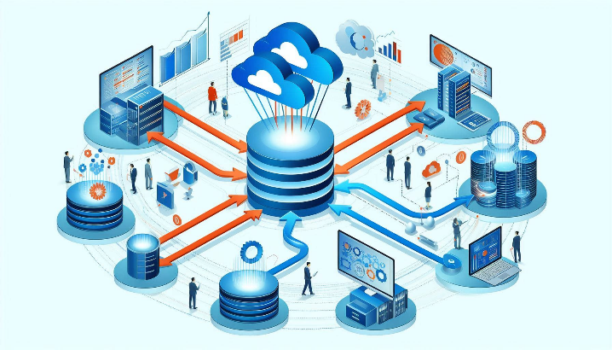

1. **Data Transformation: Enhancing Data Quality and Usability**
   * Transformation involves cleansing, validating, and formatting data to ensure consistency and accuracy.
   * Key activities include normalization, error correction, and data enrichment.
   * Azure Synapse Analytics supports these processes with powerful data processing capabilities.

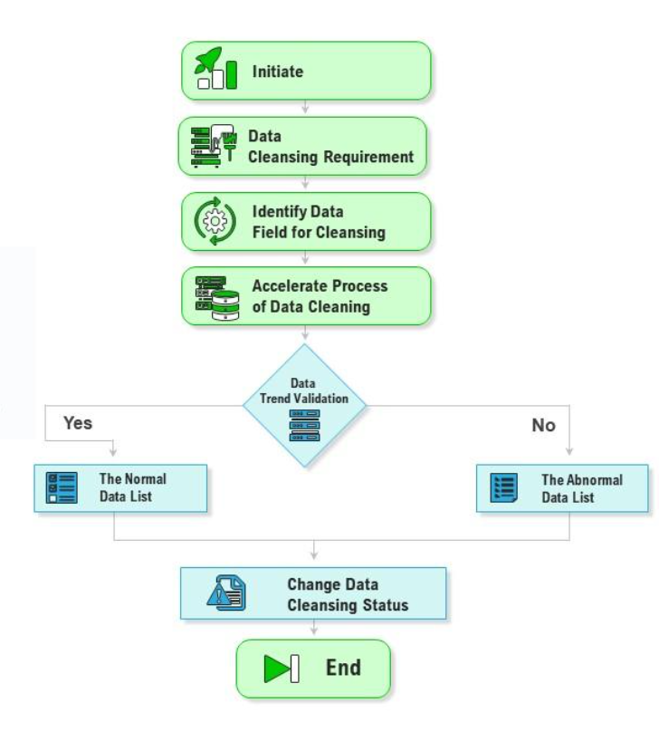

1. **Data Loading: Completing the ETL Cycle**
   * The transformed data is loaded into Azure Data Lake, a scalable storage solution.
   * Azure Data Lake organizes data in structured formats, ready for analysis and reporting.

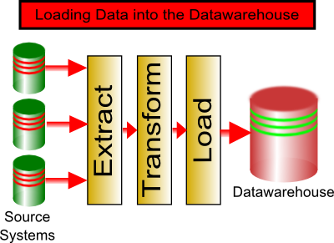

**Dollarama's Cloud Architecture: A Robust and Scalable Ecosystem**

Dollarama's cloud architecture is designed to be robust, scalable, and secure, leveraging various Azure services to create a seamless ecosystem that supports real-time data processing, advanced analytics, and multi-level data security.

Dollarama's cloud architecture incorporates a data lake architecture to optimize data management and facilitate efficient analytics. This architecture comprises three distinct layers: gold, silver, and bronze. The bronze layer serves as the raw data repository, ingesting data from various sources in its original format. The silver layer transforms and cleanses the data, applying standardization and data quality checks. Finally, the gold layer represents the curated and refined data, ready for consumption by analytical tools and business intelligence applications. This layered approach ensures data integrity, traceability, and facilitates seamless integration with Azure Synapse Analytics for advanced analysis and reporting.

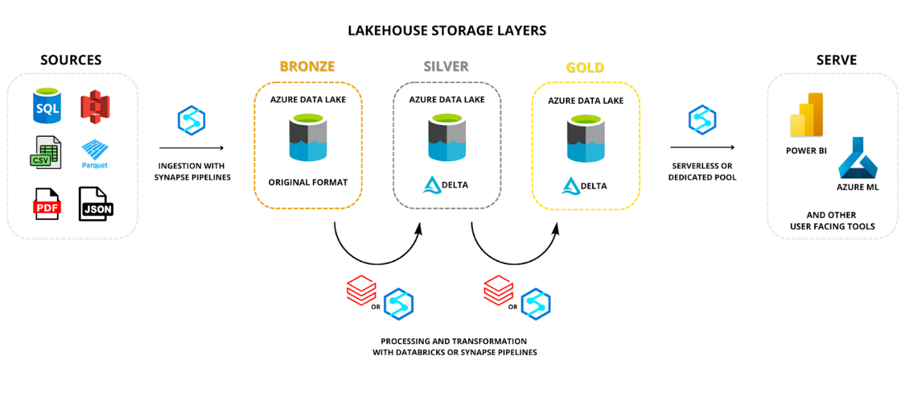

1. **Azure Data Lake Storage: Centralizing Data Storage**
   * Acts as the centralized repository for all processed data, providing scalable storage solutions.
2. **Azure Synapse Analytics: Powering Advanced Analytics**
   * Transforms raw data into actionable insights through complex analytical queries and data modeling.
3. **Azure Cosmos DB: Ensuring Low-Latency Data Access**
   * Supports applications requiring immediate data retrieval, such as real-time inventory management and customer service interfaces.
4. **Azure Event Hubs: Facilitating Real-Time Data Ingestion**
   * Captures data from various sources, like POS systems and online sales platforms, for immediate processing.
5. **Azure Logic Apps and API Management: Automating Workflows and Integration**
   * Streamlines operations and ensures seamless integration between applications and services through automated workflows and API management.

**Scalability and Security: Pillars of Cloud Architecture**

* **Scalability:** Azure's dynamic scalability tools allow Dollarama's infrastructure to scale up or down based on demand, ensuring efficiency during peak seasons without incurring unnecessary costs during slower periods.
* **Security:** Azure Security Center provides advanced threat protection services, monitoring and protecting against potential cyber threats across Dollarama's digital landscape.

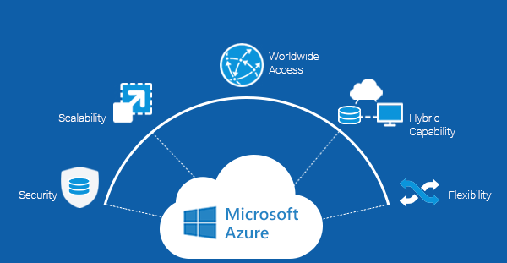

**Real-World Applications and Benefits**

1. **Operational Efficiency through Automated Inventory Management**
   * Real-time stock updates facilitated by Azure Event Hubs.
   * Automated reordering and efficient order tracking through Azure Logic Apps and API Management.
2. **Enhancing Customer Experience with Personalized Interactions**
   * Personalized offers and seamless customer service enabled by Cosmos DB's low-latency data access.
3. **Strategic Decision-Making Powered by Advanced Analytics**
   * Trend forecasting, pricing optimization, and location analytics driven by Synapse Analytics.
4. **Security and Compliance in Data Management**
   * Advanced threat protection and regulatory compliance ensured by Azure Security Center and Azure Active Directory.

**Future Outlook and Conclusion**

As technology evolves, Dollarama's cloud strategy will likely focus on advanced AI and machine learning, IoT integration, enhanced data security measures, and sustainability in cloud computing. These advancements will refine operational capabilities and solidify Dollarama's position as a leader in technology-driven retail innovation.

Dollarama's successful implementation of a robust data pipeline and cloud architecture offers a valuable blueprint for other retailers and industries looking to harness the power of cloud computing. By staying adaptive to technological advancements and proactive in strategic implementation, companies can achieve substantial gains in efficiency, customer satisfaction, and competitive advantage.

A closing image depicting a digital transformation roadmap, symbolizing strategic planning and future growth.

